**[F29DC 2024 Lab 1 –](https://canvas.hw.ac.uk/courses/28951/files/3694381?wrap=1" \o "F29DC 2024 Lab 1 - Connectivity, VPCs, Subnets, VLANs.pdf" \t "_blank) Network Topologies  
- Shyam Sundar Velmurugan  
- H00418621**

Topology B configuration

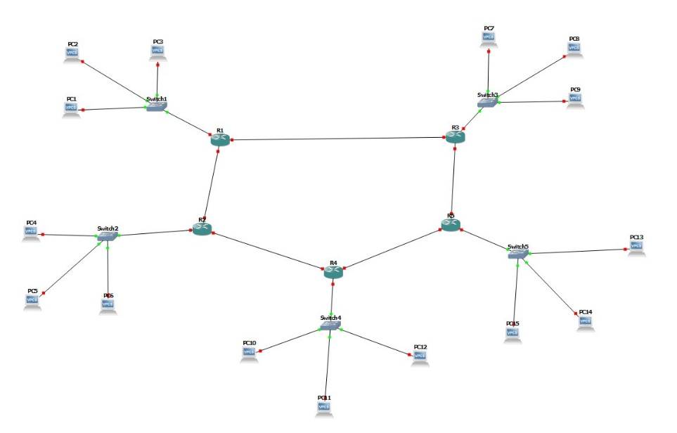

Image 2.1 : setting up all the VPC’s with their switches and respective routers to the main router.

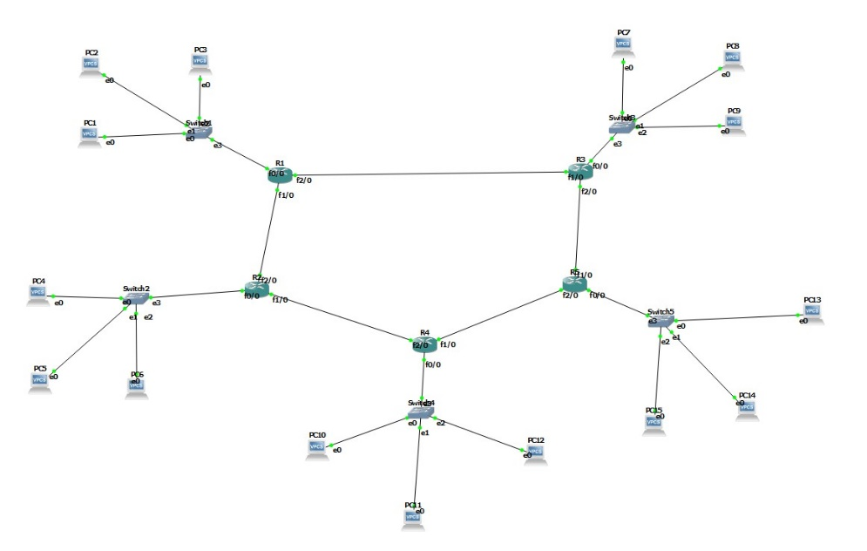

Image 2.2 : Starting the connections

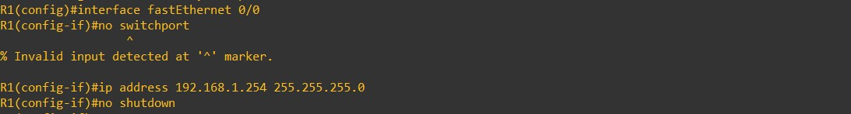D:\HERIOTT WATT\year 3 sem 1\F29DC DATA COMMUNICATIONS\LAB 5\PART 2\interfaces\ss1.jpgD:\HERIOTT WATT\year 3 sem 1\F29DC DATA COMMUNICATIONS\LAB 5\PART 2\interfaces\ss2.jpg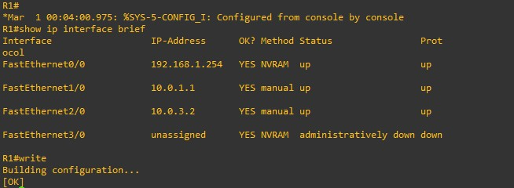

Image 2.3 : Providing ip’s for interfaces with their respective IP addresses in R1.

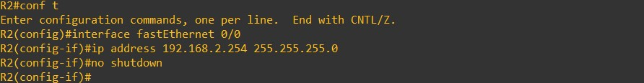 D:\HERIOTT WATT\year 3 sem 1\F29DC DATA COMMUNICATIONS\LAB 5\PART 2\interfaces\ss4.jpg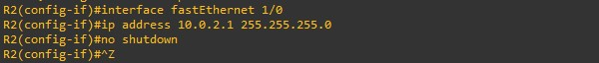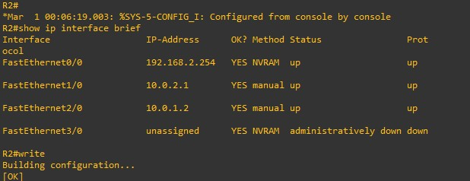

Imaagf

Image 2.4 : Providing ip’s for interfaces with their respective IP addresses in R2.

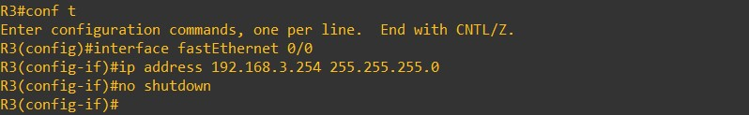 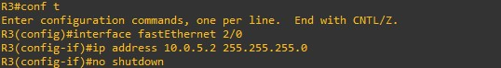D:\HERIOTT WATT\year 3 sem 1\F29DC DATA COMMUNICATIONS\LAB 5\PART 2\interfaces\ss8.jpg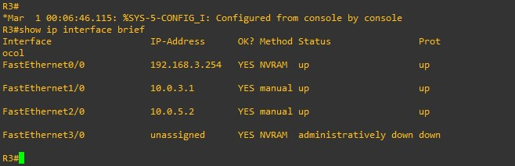

Image 2.5 : Providing ip’s for interfaces with their respective IP addresses in R3.

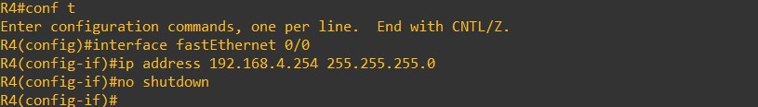 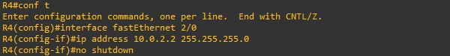D:\HERIOTT WATT\year 3 sem 1\F29DC DATA COMMUNICATIONS\LAB 5\PART 2\interfaces\ss11.jpg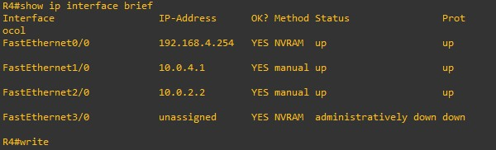

Image 2.6 : Providing ip’s for interfaces with their respective IP addresses in R4.

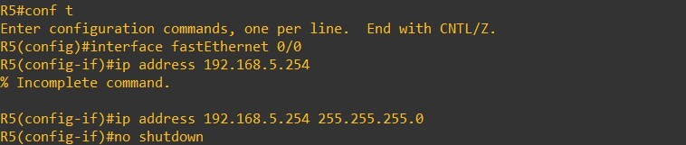 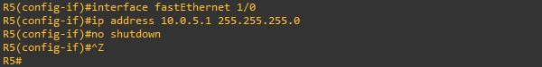D:\HERIOTT WATT\year 3 sem 1\F29DC DATA COMMUNICATIONS\LAB 5\PART 2\interfaces\ss13.jpg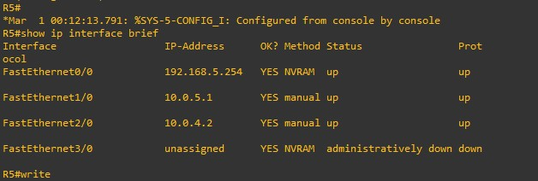

Image 2.7 : Providing ip’s for interfaces with their respective IP addresses in R5.

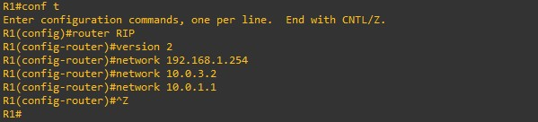

Image 2.8 : Setting up R1’s RIP configuration.

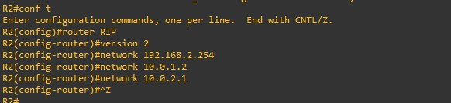

Image 2.9 : Setting up R2’s RIP configuration.

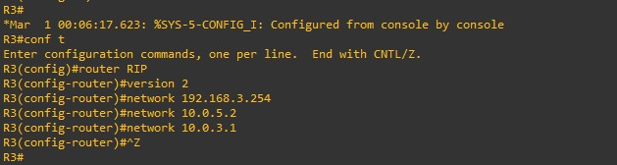

Image 2.10 : Setting up R3’s RIP configuration.

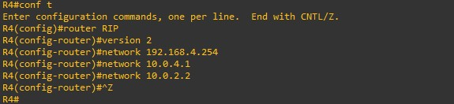

Image 2.11 : Setting up R4’s RIP configuration.

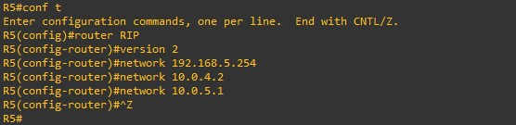

Image 2.12 : Setting up R5’s RIP configuration.

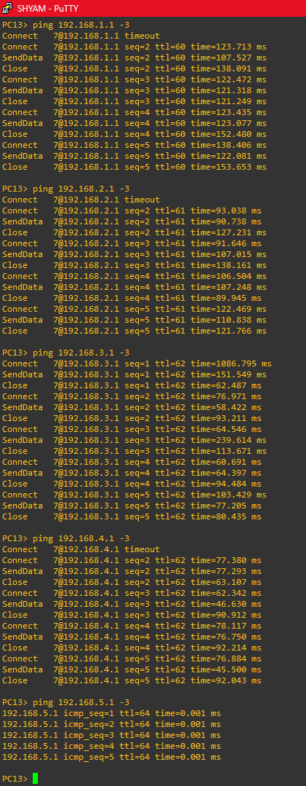

Image 2.13 : Trying to ping PC13 with all the other PCS connected to different routers.

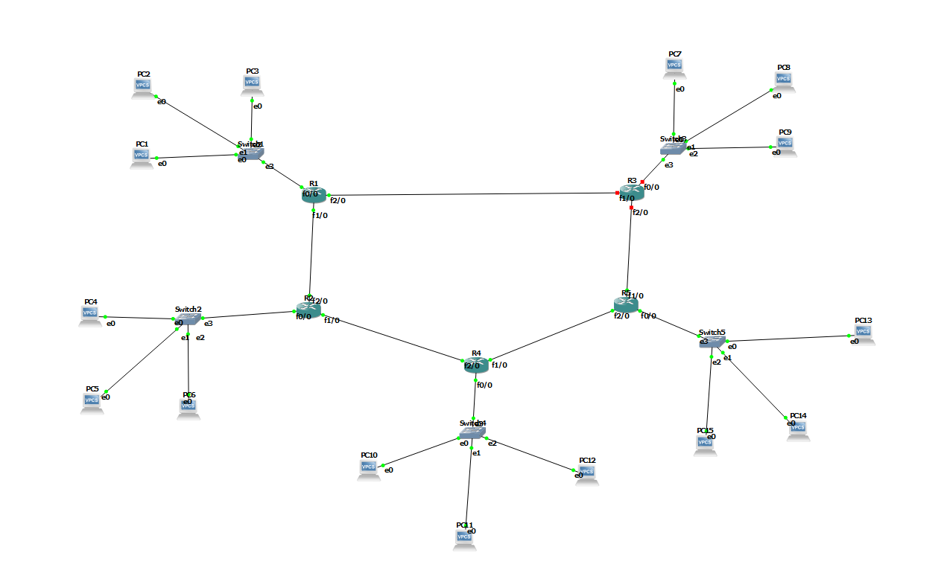

Image 2.14 : Stopping the router R3 and checking if we can ping again.

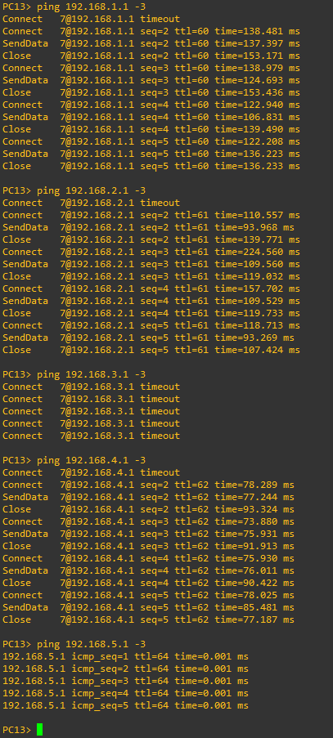

Image 2.15 : Pinging PC13 with other PC’s , connected in different routers.

We could notice that other than PC connected with R3, it can ping with PC’s connected to rest routers.

------------------------------------------------------------------------------------------------------------------------------------------